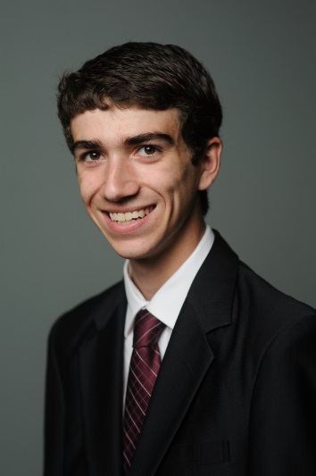

Jacob Tucker

914 Crown Pointe Estates Dr, Wildwood MO 63021

tuckerjacob20@gmail.com

(314) 570 2528

|  |  |  |
| --- | --- | --- |
| Education | | |
| 2011 – Present |  | Master of Health Sciences (MHS)  *Metropolitan State University – Saint Paul, MN*  Loremipsumdolor sitamet, consectetura dipiscingelit. Phasel lusgra vidane quenulla, non cursus neque com mo dos itamet. |
| 2010 |  | Bachelor of Science in Community Health  *St. Cloud State University – Saint Cloud, MN*  Pellentesqueelementum vitae ipsumsitameteleifend. Nullamtinciduntodio id orcia liquet mattis. Maurisdapibusnullaquisvelitpellentesquevariusegetegetlacus. |
| Leadership Activities and Awards | | |
| 2012 |  | Ut tincidunt volutpat urna. Mauris eleifend nulla eget mauris. |
| 2010 – 2012 |  | Sed cursus quam id felis. Curabitur posuere quam vel nibh. |
| 2010 – 2011 |  | Cras dapibus dapibus nisl. Vestibulum quis dolor a felis congue vehicula. |
| 2010 – 2011 |  | Maecenas pede purus, tristique ac, tempus eget, egestas quis, mauris. |
| 2009 – 2010 |  | Curabitur non eros. Nullam hendrerit bibendum justo. Fusce iaculis, est quis lacinia pretium, pede metus molestie lacus, at gravida wisi ante at libero. |
| Professional Affiliation | | |
| 2011 – Present |  | National Center of Public Health New York |
| 2011 – Present |  | Community of Health Volunteers New York |
| Work Experience | | |
| Summer 2012 |  | Health Administrator  *Fairview Health Services – Minneapolis, MN*  Pellentesqueporttitor, velitlaciniaegestasauctor, diameros tempus arcu, necvulputateaugue magna velrisus.  Cras non magna vel ante adipiscingrhoncus.  Vivamus a mi. |

|  |  |  |
| --- | --- | --- |
| 2011 – 2012 |  | Customer Service Representative  *PayDay America – Bloomington, MN*  Morbi neque.  Aliquam erat volutpat.  Integer ultrices lobortis eros.  Pellentesque habitant morbi tristique senectus et netus et malesuada fames ac turpis egestas. |
| 2010 – 2011 |  | Clinical Operations Intern  *Champaign – Urbana Public Health District – Champaign, IL*  Proin semper, ante vitae sollicitudin posuere, metus quam iaculis nibh, vitae scelerisque nunc massa eget pede.  Sed velit urna, interdum vel, ultricies vel, faucibus at, quam. |
| Winter 2009 |  | Founder, President  *Team HBV University of Illinois – Illinois*  Donec elit est, consectetuer eget, consequat quis, tempus quis, wisi.  In in nunc.  Class aptent taciti sociosqu ad litora torquent per conubia nostra, per inceptos hymenaeos.  Donec ullamcorper fringilla eros. |
| 2008 – 2009 |  | Internship  *Fairview Health Service – Minneapolis, MN*  Fusce in sapien eu purus dapibus commodo.  Cum sociis natoque penatibus et magnis dis parturient montes, nascetur ridiculus mus.  Cras faucibus condimentum odio.  Sed ac ligula. Aliquam at eros.  Etiam at ligula et tellus ullamcorper ultrices. |